**Project Name:- Flipkart**

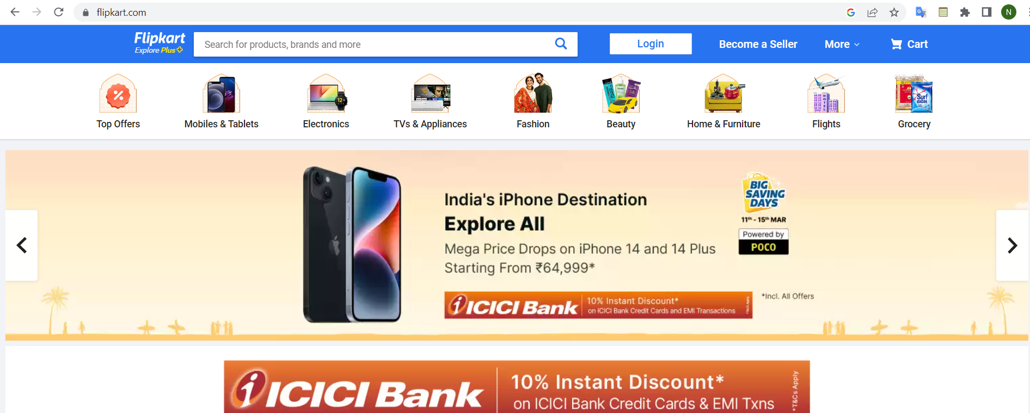

* **OVERVIEW:** It’s an e-commerce website for shopping men’s items, womens items, kids item, beauty items, mobile and tablet items ,tv and applications items , everything is available under the same roof.

The main purpose of this website user can view service categories such as consumer electronics, fashion, home essentials, groceries, and lifestyle products. user can easily buy any product quickly and receive the product within 4 days.

**User section:**

Registration/Login / Sign up Page > Home page > choose different items like- mens,womens,shoes,mobile,anything>Add to cart> Buying options > select address>Payment Gateway……

1. **Header section:**

* LOGO
* SEARCH BAR:-(search for products brands and more)
* Login:- :-( New customer sin up,my profile, orders, wishlist,rewards,gift Cards)
  + - * Become a seller
      * More:- (Notifications, cutomer care services, advertise)
      * ADD to cart- (some add items )

**HOME PAGE:**

* Top offers:-
* Fashion:-(mens,womens,beauty,)
* Mens section:- dropdown list-(jeans>shirt>t-shirt>causul paint>shoes>sleepers)
* Womens sections:-dropdown list-(top>sarries>sandal>kurti>lehga>jeans>shirt>t-shirt)
* Mobile and tablets:-dropdown list-(samsung>oppo>vivo>realme>micromax)
* Electronics:-(Tv>freeze>irons)
* Beauty:-drop down list(beauty and grooming>jewellery>)
* Home & furniture(Home decor>Home lighting>festival decor &gifts)
  + - * SLIDERS WITH ARROWS - (IMAGES)
      * DEALS - (IMAGES)
* FEATURED - (IMAGES)
* TRENDING - (IMAGES)
* FOOTER – ( CONTACT US , HELPLINES , BRIEF DESCRIPTION:- (ABOUT THE COMPANY , SOCIAL-MEDIA HANDLE ICONS , LINK TO MOBILE APP )
* Technologies used in Flipkart……
* Front-End:
* Html
* Css
* Bootstrap
* React
* Dynamic:
* Javascript
* Ci/cd with AWS
* Login and Logout (oauth and jwt)
* Database:
* Mongodb
* Json Data
* Code compilers:
* Visual studio code
* Git bash
* Git hub
* Node js

1. **PAYMENT PAGE:**

* PAYMENT METHOD - (PHONEPE , GOOGLE PAY , BHIM UPI , COD , CREDIT/DEBIT CARD , NET - BANKING , EMI , PAYTM)